**L.A.L. County wide league management opportunities. Including: Grounds & Facilities; Fixtures/Referees; Equality, Inclusion Diversity & Safeguarding; Discipline; Marketing etc. You are invited to join our League Management Committee** and help us to deliver planned football developments across Lancashire County.

⚽️Do you have the enthusiasm and desire to give back or make a difference to football in our Lancashire communities?

⚽️Are you currently involved with one of our member clubs?

⚽️Are you a qualified Referee?

⚽️Do you have IT skills &/or experience of scheduling & re-scheduling fixtures to deliver league/competitions?

⚽️Do you have marketing skills &/or experience of Web site development and/or optimising social media channels?

⚽️Do you have knowledge, skills, understanding of Equality, Inclusion, Diversity & Safeguarding requirements?

**If so** we want you to join us. We are committed to involving our member clubs in getting our football offer right. In addition we now have very strong links with the County FA, which is a vital part in ensuring Grass roots football provides a quality contemporary offer to players and officials.

**If you have, and you’d like to make a difference get in touch.** We are happy to discuss the roles and share what we intend to focus on and how we intend to go about it.

These roles are about running football over several divisions across the County. These jobs are vital to deliver County wide football. But don’t be put off by thinking it may be too much to take on. We can tailor your contributions. We have several members who have lots of experience and who will be happy to help induct you and provide advice and support.

These positions don’t crop up very often so don’t hesitate to Contact Peter Duffy Hon. Sec. ([lal.secretary@gmail.com](mailto:lal.secretary@gmail.com)), Simon Lord League Chairman ([simjenmik@zen.co.uk](mailto:simjenmik@zen.co.uk)), or Pete Jackson Vice Chairman ([jacksonlymm@ntlworld.com](mailto:jacksonlymm@ntlworld.com)).

**Please note some of these positions attract financial remuneration, via an honorarium.**

**JOIN US TO MAKE FOOTBALL IN THE L.A.L. THE BEST AVAILABLE.**

⚽️⚽️⚽️⚽️⚽️⚽️⚽️⚽️⚽️⚽️⚽️

The Lancashire Amateur League provides adult Saturday football across Lancashire. Formed in 1899 we now have over 80 teams across 6 Divisions and are an England Football Accredited League.

⚽️⚽️⚽️⚽️⚽️⚽️⚽️⚽️⚽️⚽️⚽️

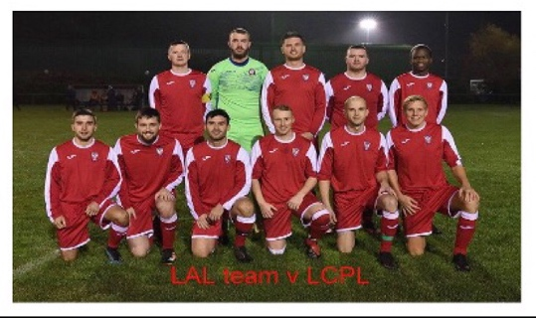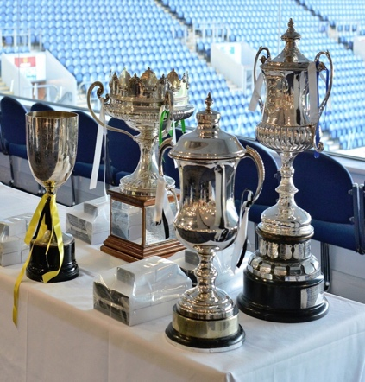B

**The LAL Management Committee has an under representation of Black & Minority Ethnic communities involved in managing our league. We are also keen to encourage more females to play their part in running a grassroots football league. We would also welcome applicants with disabilities to join us, as we believe football is an inclusive sport for everyone..**